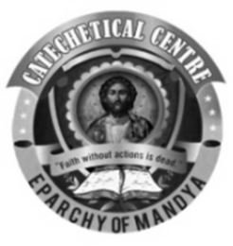
COMMISSION FOR BIBLE AND CATECHETICS
EPARCHY OF MANDYA

SUNDAY CATECHISM
TRANSFER CERTIFICATE APPLICATION
(PLEASE FILL IN BLOCK LETTERS)

HOLY FAMILY FORANE CHURCH, HONGASANDRA

http://www.holyfamilyforanechurch.com/
STUDENT’S NAME
FAMILY NAME
GENDER (MALE / FEMALE)
DATE OF BIRTH (dd-mm-yyyy)
BAPTISMAL NAME
DATE OF BAPTISM
(dd-mm-yyyy)
DATE OF CONFIRMATION
(dd-mm-yyyy)
FATHER’S NAME
MOTHER’S NAME
COMMUNICATION ADDRESS

CONTACT NUMBER
STANDAD IN WHICH THE STUDENT LAST STUDIED
REASON FOR LEAVING
PARISH TO WHICH THE STUDENT INTENDS PROCEEDING

(FOR OFFICE USE ONLY)
TRANSFER CERTIFICATE (TC) NUMBER
TRANSFER CERTIFICATE ISSUE DATE
WHETHER QUALIFIED FOR PROMOTION TO THE NEXT STANDARD
NUMBER OF SCHOOL DAYS THE STUDENT ATTENDED
MARKS OBTAINED
REMARKS IF ANY

Submit the completed application form in the catechism office on Sundays between 9:30 AM and 12:00 PM.
For enquiries, please contact 8550054443

